PHASE 4: PROJECT PLANNING PHASE

4.1 Project Planning
The project is divided into different activities to ensure systematic development.
Activity | Description
Requirement Analysis | Identify helpdesk problems and requirements
Table Creation | Create custom IT ticket table
Field Configuration | Create required fields
Choice Configuration | Configure Category, Subcategory and State
Dependency Configuration | Connect Category and Subcategory
Flow Development | Create automatic classification flow
Email Configuration | Configure caller notification
Testing | Test different ticket scenarios
Documentation | Prepare project documentation
Demonstration | Demonstrate complete workflow

4.2 Update Set Planning
A ServiceNow Update Set named:
Project Update Set
is created to store project configuration changes.

Update Set Details
Name: Project Update Set
State: In Progress
Application: Global
The Update Set allows the project configuration to be transferred to another ServiceNow instance.

4.3 Testing Plan
The following test cases are planned:

Test Case | Input | Expected Result
TC01 | WiFi not working | Network → Wi-Fi
TC02 | Projector not turning on | Hardware → Projector
TC03 | Forgot password | Access → Forgot Password
TC04 | Computer is slow | Performance → Slow Computer

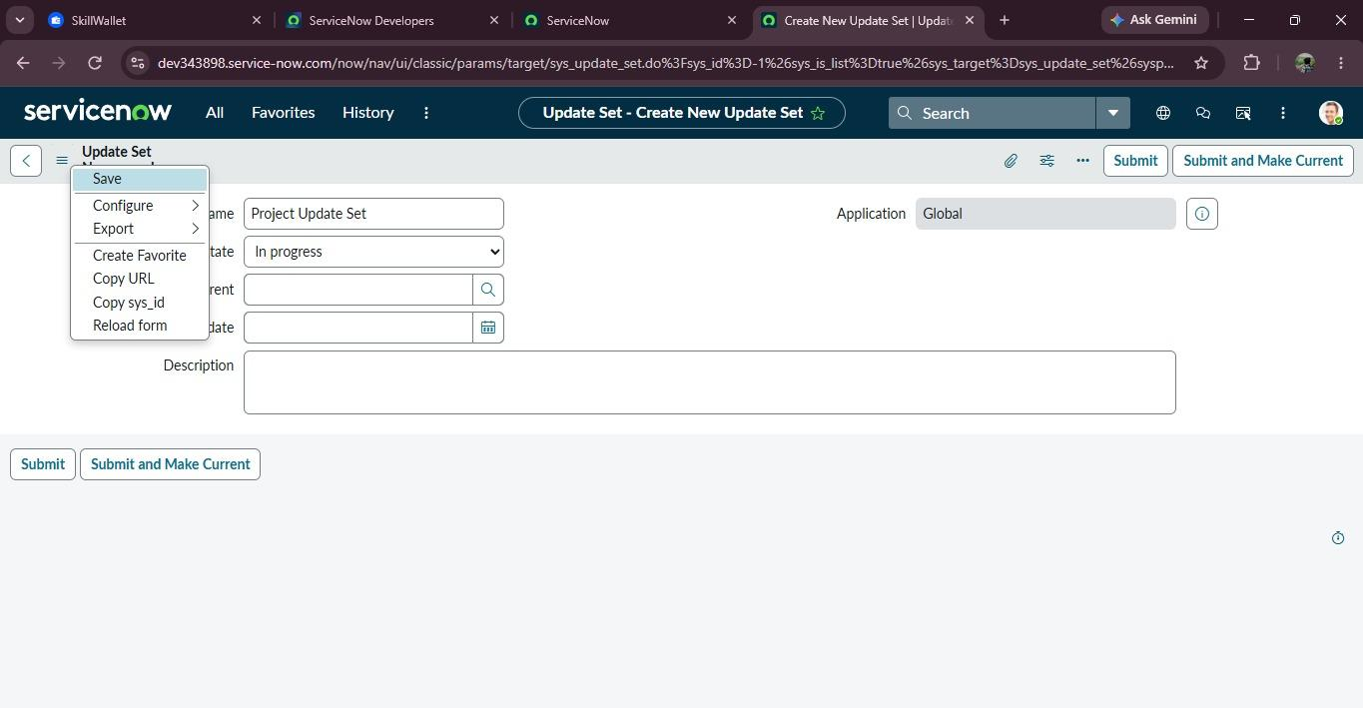
Fig 4.1:Project Update Set created for managing ServiceNow configuration changes.

